How to register for an Online Services account with Patient Access

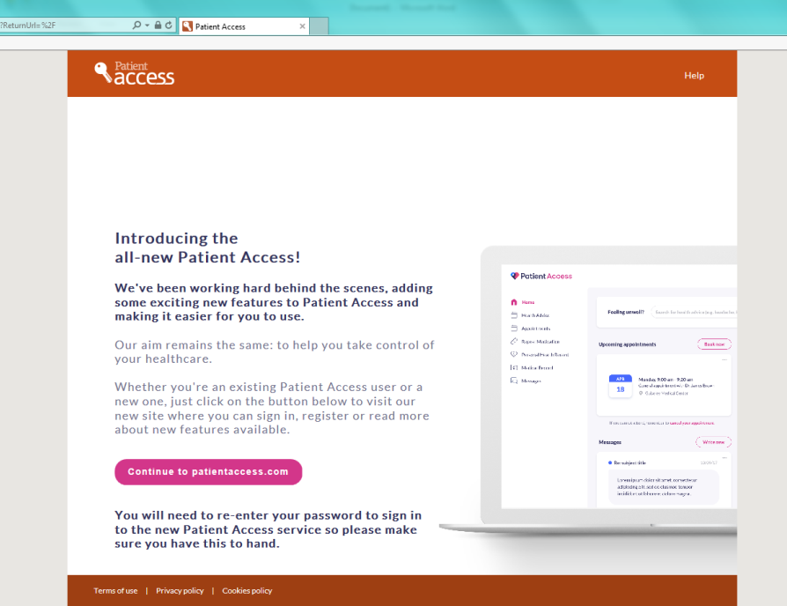
https://patient.emisaccess.co.uk

This is the Homepage that will open up once you have typed in the above website address.

Click on the ‘Continue to patient access’ button.
This will take you to another page.

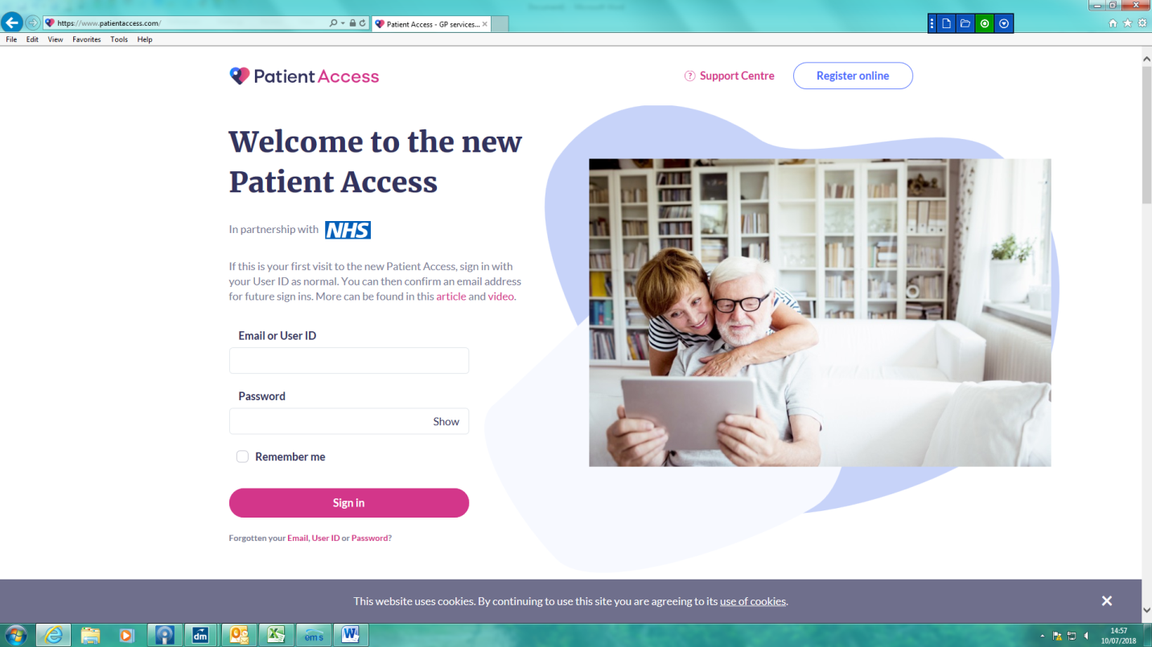

Once you are on this page click on the ‘Register Online’ button in the top right corner.

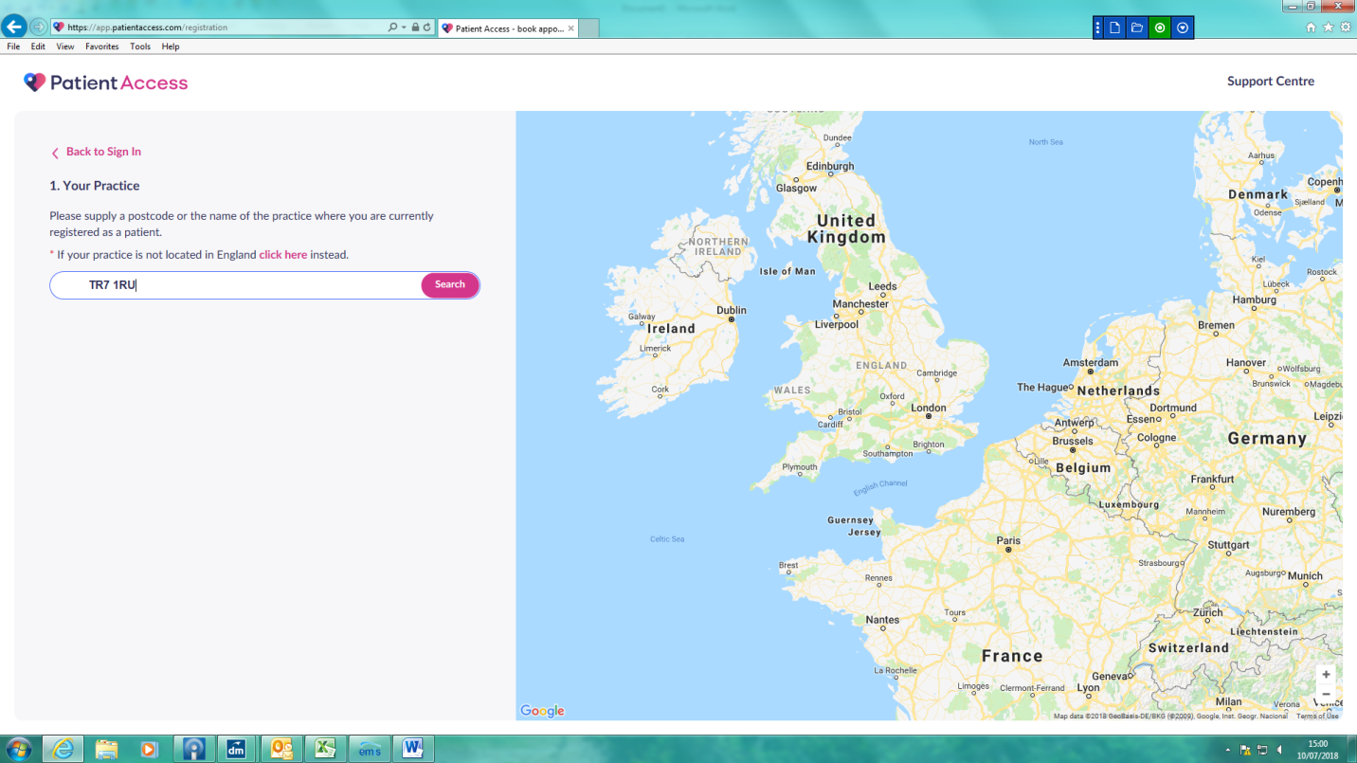

Enter the surgery post code ‘TR7 2QF’ and click on Narrowcliff Surgery .
Then press continue.

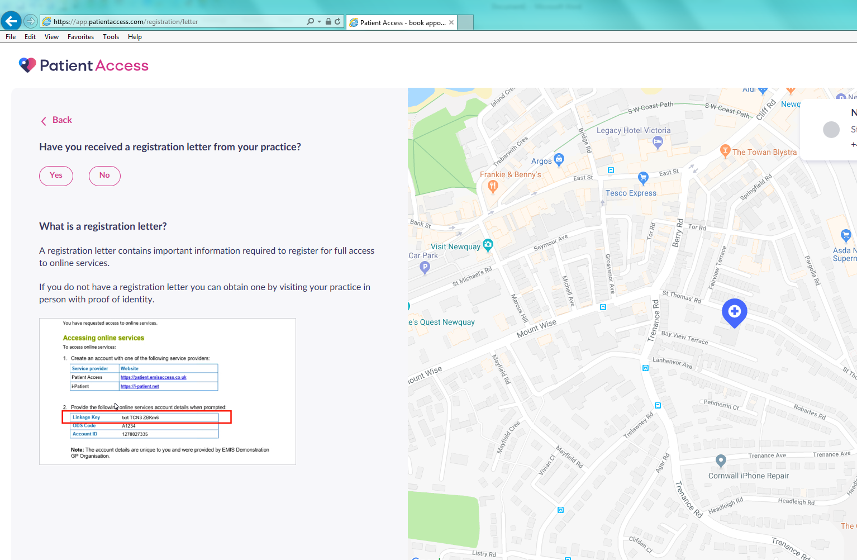

Click ‘Yes’ as you will have your own registration letter that your GP surgery will have given you.

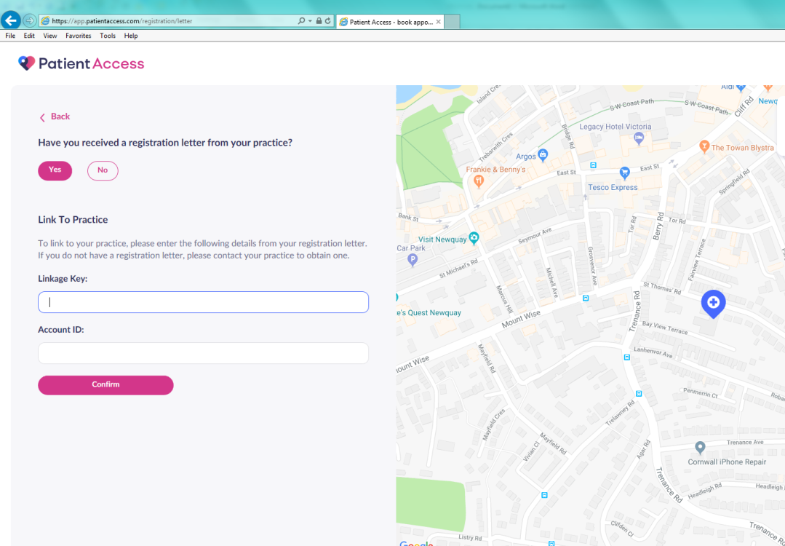

You will need to fill in your Account Linkage Key & Account ID which you will find on your registration letter.
Please note that it is case sensitive.
Once you have completed this you will be logged into your account.

